**For Warehouse:-**

**CREATE DATABASE Warehouse;**

**For Sales order table:-**

* CREATE TABLE Sales_Order ( Order_no INT AUTO_INCREMENT PRIMARY KEY, Total_order_qty INT, Customer_number VARCHAR(50), Entry_system_date DATE, Request_ship_date DATE, Comments VARCHAR(50), Shipping_address VARCHAR(100));
* INSERT INTO `sales_order`(`Order_no`, `Total_order_qty`, `Customer_number`, `Entry_system_date`, `Request_ship_date`, `Comments`, `Shipping_address`) VALUES (`001`,`15`,`c-101`,`2015/3/12`,`2015/3/20`,`-`,`71 Pilgrim Avenue Chevy Chase,USA 20815`)

**For Sales Details table:-**

* CREATE TABLE Sales_Details ( Order_no INT NOT NULL, Order_line_number INT,Order_qty INT, Product_code VARCHAR(50),Product_description VARCHAR(50),Discount_value VARCHAR(50) , Comments VARCHAR(50), FOREIGN KEY fk_memb(Order_no) REFERENCES sales_order(Order_no));
* INSERT INTO `sales_details`(`Order_no`, `Order_line_number`, `Order_qty`, `Product_code`, `Product_description`, `Discount_value`, `Comments`) VALUES ('1001','1','4','p-508','Granier shampoo 10.3OZ','1.2$','-')
* INSERT INTO `sales_details`(`Order_no`, `Order_line_number`, `Order_qty`, `Product_code`, `Product_description`, `Discount_value`, `Comments`) VALUES ('1001','2','6','p-511','Baby care oil 4 OZ','0.5$','-')
* INSERT INTO `sales_details`(`Order_no`, `Order_line_number`, `Order_qty`, `Product_code`, `Product_description`, `Discount_value`, `Comments`) VALUES ('1001','3','2','p-201','Baby food nestle 500gm','0.3$','-')
* INSERT INTO `sales_details`(`Order_no`, `Order_line_number`, `Order_qty`, `Product_code`, `Product_description`, `Discount_value`, `Comments`) VALUES ('1001','4','3','p-401','Loreal hair oil 12OZ','2$','-')

**For Dispatched table:-**

* CREATE TABLE Dispatched ( Order_no INT NOT NULL, Order_line_number INT,Order_qty INT, Qty_approved INT, Unit_price VARCHAR(50),Net_sales_value VARCHAR(50),Active_flag VARCHAR(50) , Dispatched_date DATE, FOREIGN KEY fk_memb(Order_no) REFERENCES sales_order(Order_no));
* INSERT INTO `dispatched`(`Order_no`, `Order_line_number`, `Order_qty`, `Qty_approved`, `Unit_price`, `Net_sales_value`, `Active_flag`, `Dispatched_date`) VALUES ('1001','1','4','3','7$','21$','T','2015/3/18')
* INSERT INTO `dispatched`(`Order_no`, `Order_line_number`, `Order_qty`, `Qty_approved`, `Unit_price`, `Net_sales_value`, `Active_flag`, `Dispatched_date`) VALUES ('1001','2','6','2','9$','18$','T','2015/3/18')
* INSERT INTO `dispatched`(`Order_no`, `Order_line_number`, `Order_qty`, `Qty_approved`, `Unit_price`, `Net_sales_value`, `Active_flag`, `Dispatched_date`) VALUES ('1001','3','2','2','20$','40$','T','2015/3/17')
* INSERT INTO `dispatched`(`Order_no`, `Order_line_number`, `Order_qty`, `Qty_approved`, `Unit_price`, `Net_sales_value`, `Active_flag`, `Dispatched_date`) VALUES ('1001','4','3','3','10$','30$','T','2015/3/15')

**For Customer Table:-**

* CREATE TABLE customer (Customer_number VARCHAR(50), Customer_name VARCHAR(50), Telephone VARCHAR(50), Email VARCHAR(50), Street VARCHAR(50), Zipcode INT, City VARCHAR(50), Country VARCHAR(50))
* INSERT INTO `customer`(`Customer_number`, `Customer_name`, `Telephone`, `Email`, `Street`, `Zipcode`, `City`, `Country`) VALUES ('C-101','Clair Doe','+4100006589','clair101D@yahoomail.com','71,Pilgrim Avenue','20815','Chevy Chase','USA')
* INSERT INTO `customer`(`Customer_number`, `Customer_name`, `Telephone`, `Email`, `Street`, `Zipcode`, `City`, `Country`) VALUES ('C-102','John Wick','+4100076589','JohnWick@yahoomail.com','5th Avenue','20818','Chicago','USA')
* INSERT INTO `customer`(`Customer_number`, `Customer_name`, `Telephone`, `Email`, `Street`, `Zipcode`, `City`, `Country`) VALUES ('C-103','Bruce Wayne','+4100076500','Bwayne@yahoomail.com','Wayne Mansion','20452','Gotham','USA')
* INSERT INTO `customer`(`Customer_number`, `Customer_name`, `Telephone`, `Email`, `Street`, `Zipcode`, `City`, `Country`) VALUES ('C-104','Clark Kent','+4100084500','Ckent@yahoomail.com','14,Daily Planet','20852','Metroplois','USA')
* INSERT INTO `customer`(`Customer_number`, `Customer_name`, `Telephone`, `Email`, `Street`, `Zipcode`, `City`, `Country`) VALUES ('C-105','Berry Allen','+4105084500','Barryaln@yahoomail.com','14,Jitters','20856','Central City','USA')
* INSERT INTO `customer`(`Customer_number`, `Customer_name`, `Telephone`, `Email`, `Street`, `Zipcode`, `City`, `Country`) VALUES ('C-106','Oliver Queen','+4105784500','Oqueen@yahoomail.com','Queen Mansion','20836','Star City','USA')
* INSERT INTO `customer`(`Customer_number`, `Customer_name`, `Telephone`, `Email`, `Street`, `Zipcode`, `City`, `Country`) VALUES ('C-107','Nick Klaus','+4101784500','Klaus@yahoomail.com','Michealson Quaters','20836','New Orleans','USA')

**Q1. Find the total sales order wise, having following details:  order no, customer name , total ordered qty, qty dispatched, total sales, dispatched date**.

**Ans.** SELECT Order_no, customer.Customer_name, total_orderd_qty, total_sales, DATE_FORMAT(dispatched_date, '%d-%m-%Y') AS Dispatched_date

FROM customer

INNER JOIN

(

SELECT dispatched.Order_no, sales_order.Customer_number, SUM(Order_qty) As total_orderd_qty, SUM(Net_sales_value) As total_sales, Max(Dispatched_date) As dispatched_date

FROM sales_order

JOIN dispatched ON sales_order.order_no=dispatched.order_no

GROUP BY order_no

)As A ON A.Customer_number=customer.Customer_number

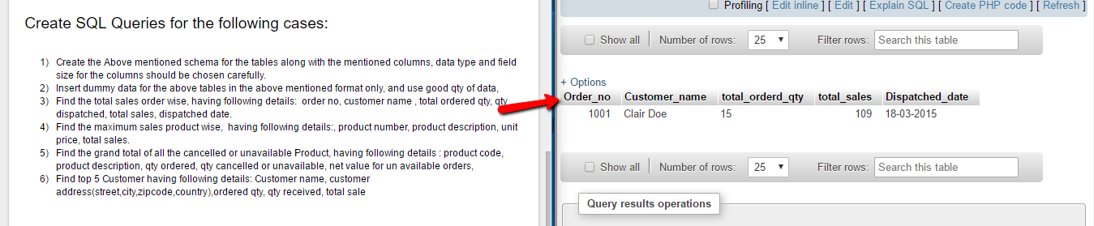

**Q2. Find the maximum sales product wise, having following details:, product number, product description, unit price, total sales.**

**Ans.** SELECT Product_code, Product_description, Unit_price, SUM(Qty_approved)

FROM dispatched

JOIN sales_details ON dispatched.Order_line_number=sales_details.Order_line_number

GROUP by product_code, product_description, unit_price

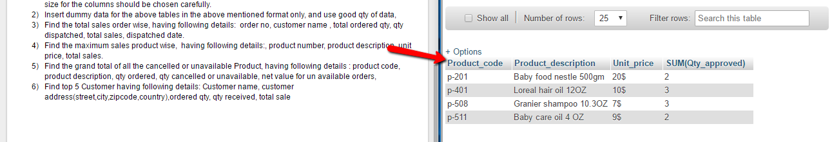

**Q3. Find the grand total of all the cancelled or unavailable Product, having following details : product code, product description, qty ordered, qty cancelled or unavailable, net value for un available orders,**

ANS. SELECT Product_code, Product_description, dispatched.Order_qty, (dispatched.Order_qty-Qty_approved) AS Qty_cancelled,((dispatched.Order_qty-Qty_approved)*Unit_price) AS Net_value_unavailable

FROM dispatched

JOIN sales_details ON dispatched.Order_line_number=sales_details.Order_line_number

GROUP by product_code, product_description, unit_price, dispatched.Order_qty, Qty_approved

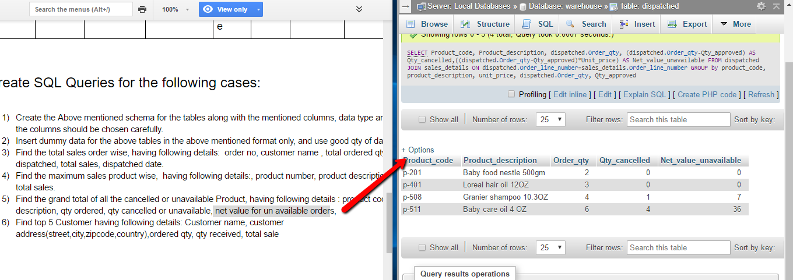

**Q4. Find top 5 Customer having following details: Customer name, customer address(street,city,zipcode,country),ordered qty, qty received, total sale**

**ANS.** SELECT Customer_name,address,SUM(dispatched.Order_qty) as Ordered_Quantity, SUM(dispatched.Qty_approved) as Quantity_recived ,SUM(dispatched.Net_sales_value) as Total_Sales FROM dispatched INNER JOIN(SELECT Customer_name,concat(Street,',',City,',',Country,',ZIP-',Zipcode)as Address, Order_no from customer INNER JOIN sales_order ON sales_order.Customer_number=customer.Customer_number) t1 on dispatched.Order_no=t1.Order_no GROUP BY t1.Order_no ORDER BY Total_sales DESC LIMIT 5

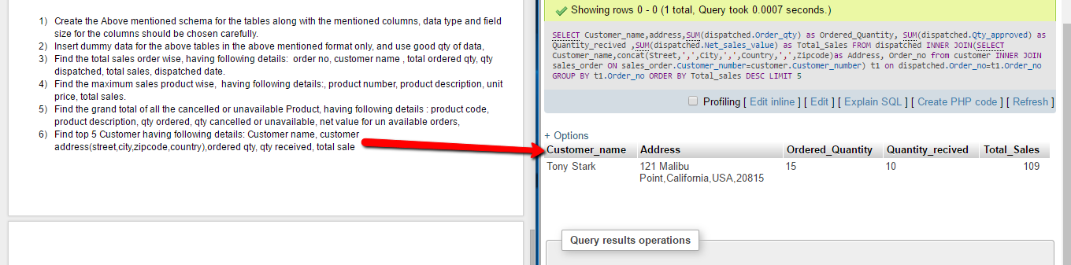

**Q5. Find top 5 selling product having following details, product no, product description, gross sales of product, net sales of product.**

**ANS.** SELECT Product_code, Product_description, sum(Net_sales_value) AS Net_Sales,(sum(Qty_approved)*(Unit_price-Discount_value)) AS Gross_sale from sales_details INNER JOIN dispatched on sales_details.Order_qty= dispatched.Order_qty GROUP BY Product_code,Product_description, Unit_price,Discount_value LIMIT 5

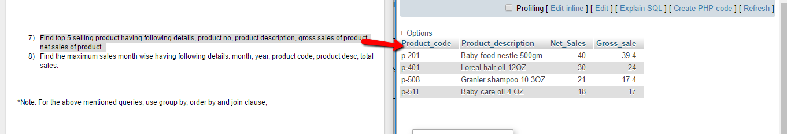

**Q6.** **Find the maximum sales month wise having following details: month, year, product code, product desc, total sales.**

**ANS.** SELECT sales_details.Product_code as product,sales_details.Product_description as decs,MONTH(dispatched.Dispatched_date)MONTH, YEAR(Dispatched.Dispatched_date)YEAR, SUM(dispatched.Net_sales_value)SALES from dispatched INNER JOIN sales_details on dispatched.Order_line_number=sales_details.Order_line_number GROUP BY product_code)t1 GROUP BY Month

